**Aim**: Configure DHCP server.

**Step – 1:-** Open the Cisco Packet tracer and take three Router.

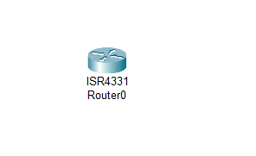

**Step – 2 :-**  Take Three Switches

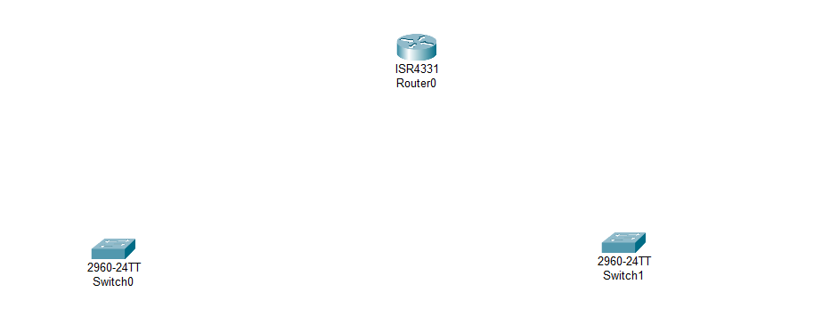

**Step – 3 :-**  Now Take 6 PC’s.

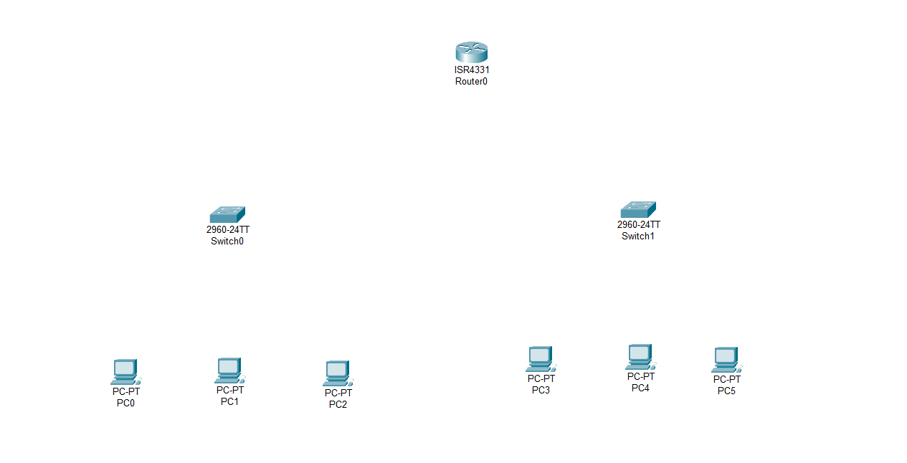

**Step – 4 :** Make Connections of PCs with Switches and Switches with the Router using copper straight-through cable.

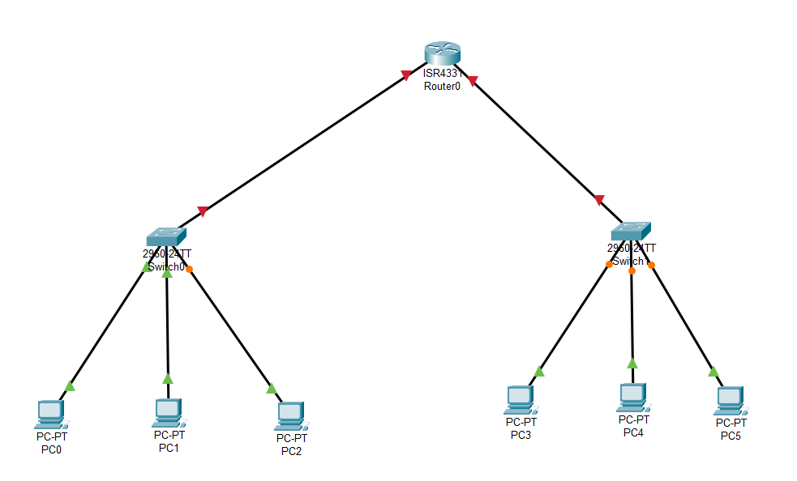

**Step – 5 :-**  Assign the IP Address to the both Ports of the Routers.

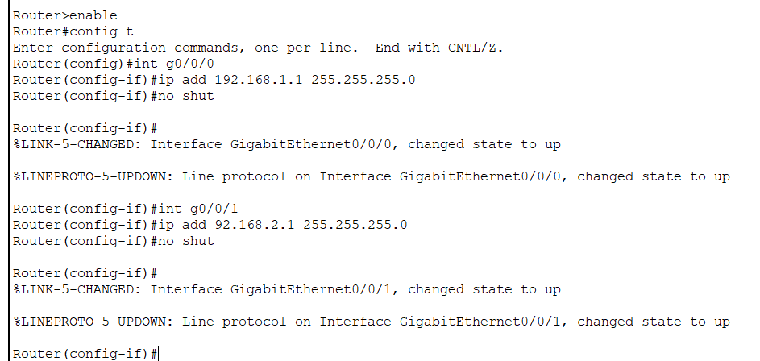

**Step – 6:-**  Now Exclude the IP address assigned to the Ports of the router.

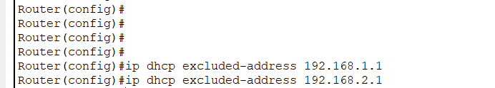

**Step – 7 :-**  Create IP DHCP Pool for network 192.168.1.0

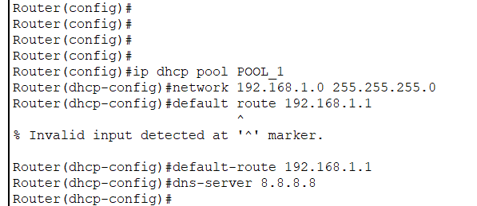

* **ip dhcp pool POOL_1 :-** This command creates a new DHCP pool called POOL_1. A DHCP pool is a range of IP addresses that can be assigned dynamically to clients on the network.
* **network 192.168.1.0 255.255.255.0 :-** This command specifies the network address and the subnet mask for the DHCP pool. In this case, the network is 192.168.1.0 with a subnet mask of 255.255.255.0. The DHCP server has the provision to assign an IP address to any of the clients connecting to it within the range of 192.168.1.1-192.168.1.254.
* **default-route 192.168.1.1** :- this command specifies the default gateway.
* **dns-server 8.8.8.8 :-** this will provide the address of DNS server.

**Step – 8 :-**  Create IP DHCP Pool for network 192.168.2.0

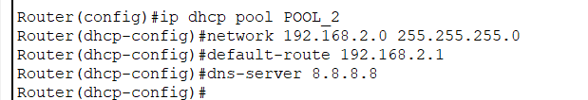

* **ip dhcp pool POOL_2 :-** This command creates a new DHCP pool called POOL_2. A DHCP pool is a range of IP addresses that can be assigned dynamically to clients on the network.
* **network 192.168.2.0 255.255.255.0 :-** This command specifies the network address and the subnet mask for the DHCP pool. In this case, the network is 192.168.2.0 with a subnet mask of 255.255.255.0. The DHCP server has the provision to assign an IP address to any of the clients connecting to it within the range of 192.168.2.1-192.168.2.254.
* **default-route 192.168.2.1** :- this command specifies the default gateway.
* **dns-server 8.8.8.8 :-** this will provide the address of DNS server.

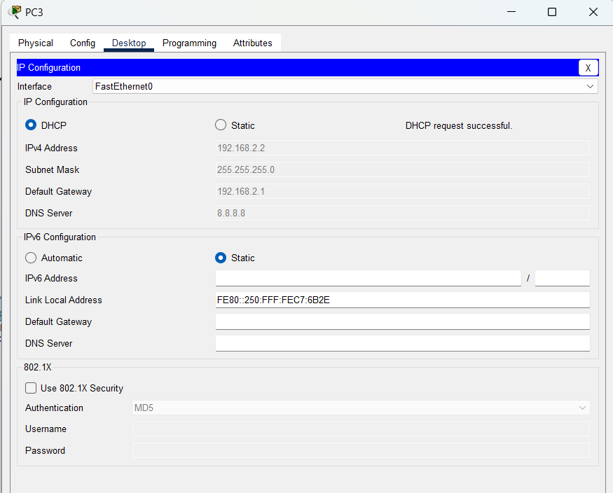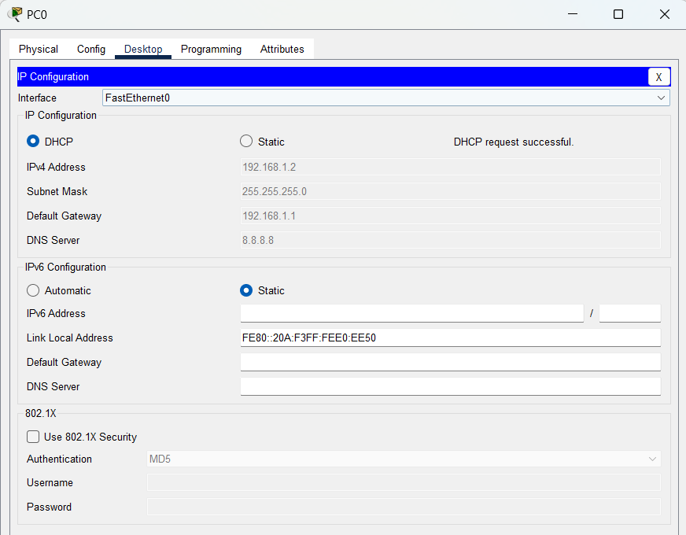**Step – 9 :-**  now we will configure the IP Address of the PC’s using DHCP.

**Step – 10 :-**  Now we will check the connectivity using ping command.

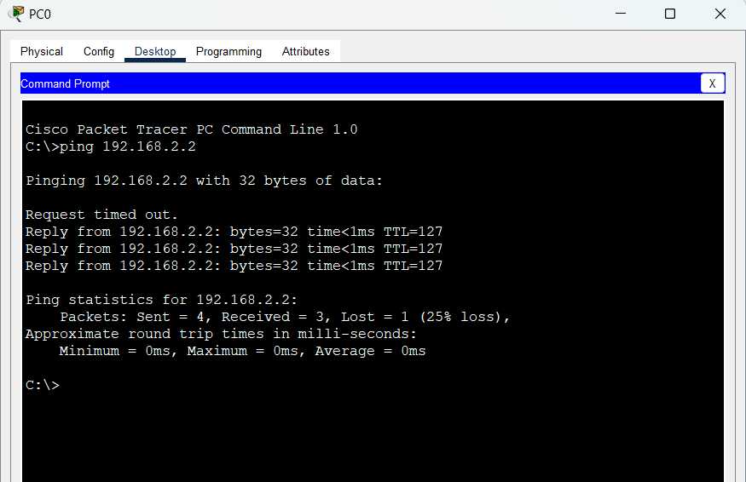

* We are getting the reply. means that we are able to assign the IP address dynamically to the devices in the network.

**Conclusion :-**

By Performing this experiment, we learned how to configure the router as a DHCP server, how to create an IP POOL, how to assign the range of IP addresses in that pool, assign the DNS server address, and how to assign the default gateway .and learned how to make successful communication by the effective use of IP address and minimize the wastage of IP address.